Deliverable 3: Memory Management and Process Synchronization
Vikram Reddy Tekula, Raghav Gurram
Shiva Gowtham Kumar, Sri Varshini Sukhamanchi
University of the Cumberlands
Advanced Operating Systems (MSCS-630-M20)
Professor Sean Perryman
October 24, 2026

Introduction
Modern OS coordinate physical memory and concurrent activities so that resources remain intact: paging maps process-owned virtual pages to fixed-size physical frames; synchronization prevents workers running concurrently from corrupting shared structures. Deliverable 1 built a Python Unix-like shell with builtins, external program execution (os.fork(), os.execvp), process groups and job control. This deliverable keeps the structure but adds educational simulators for paging and the producer–consumer problem. The mechanisms added run inside the shell and don't replace the Linux kernel's virtual-memory or thread scheduler. Research comparing replacement algorithms suggests measuring page faults instead of assuming universal superiority (Abbas et al., 2022).

Memory Management Implementation
The new memory_sync.py module defines a Paging class with a configurable number of fixed-size frames, a default page size (4096 bytes) and per-process virtual page sets. mem init 3 FIFO is accepted by the shell; mem access P1 0 mem status mem free P1 mem compare. Each page is identified by tuple (process ID, virtual page number); two different processes may therefore reference page zero without sharing the same physical frame. The frame table keeps insertion and last access sequence numbers and resident physical memory in bytes.
If the requested page is already resident, then a hit is recorded, and the access timestamp is updated; otherwise, a page fault is recorded, an empty frame is allocated if possible, and a victim is evicted when every frame is occupied (FIFO selects the oldest insertion sequence; LRU selects the least recently accessed). Replacement keeps the virtual-page record but removes the evicted mapping from physical residence. Deallocation frees all frames in the resident set belonging to a process and removes its tracked virtual allocations (Tareef et al., 2025). This models central replacement-policy choices correctly, although real operating systems also maintain hardware page tables, dirty bits, backing stores, protection permissions, and disk I/O.

Page Replacement Results
Both algorithms were tested on the same reference sequence 1, 2, 3, 1, 4, 1, 2, 5, 1, 2, 3, 4 with three frames and all references attributed to P1. Each new page caused a fault, and accesses to resident pages caused hits. The following table gives results calculated by running the submitted Python implementation rather than hypothetical estimates.
Algorithm | References | Faults | Hits | Evictions
FIFO | 12 | 9 | 3 | 6
LRU | 12 | 8 | 4 | 5

FIFO had a miss rate of 75.0% vs. 66.7% for LRU, so LRU avoided one fault on this trace. Three 4,096-byte frames = 12,288 bytes of resident memory, regardless of how many different virtual pages the trace referenced (page replacement does not increase physical capacity). FIFO can sometimes beat LRU for certain sequences (Kim, 2025). Adaptive work also shows that recency policies can be improved by learning workload characteristics.

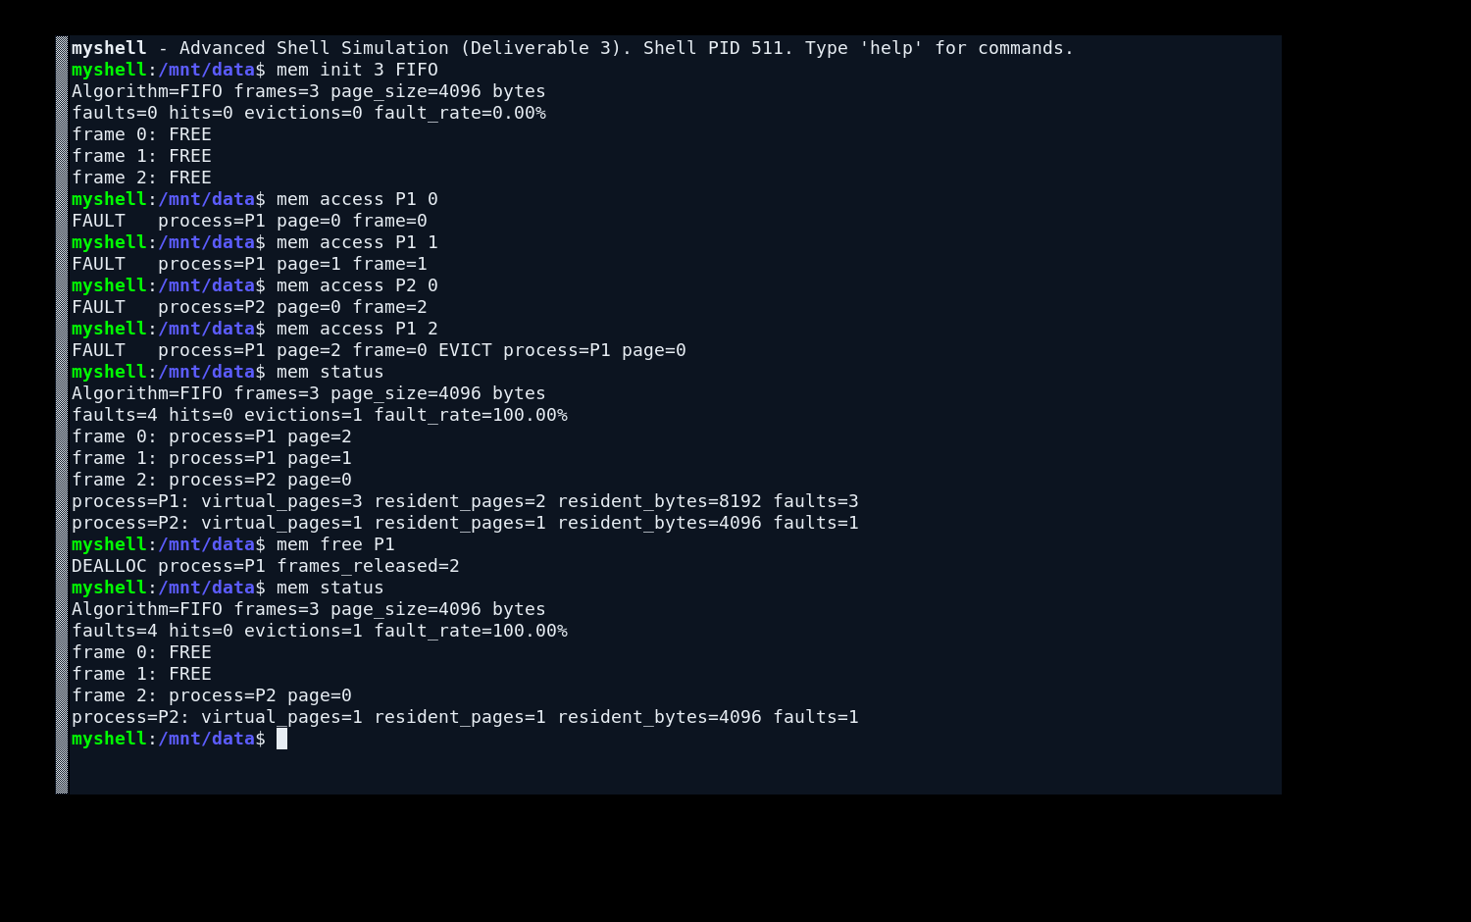
Figure 1. Memory allocation, page faults, FIFO page replacement, memory usage, and process deallocation.

Memory Allocation and Deallocation Demonstration
The shell demonstration initializes three frames, allocates pages to P1 and P2, forces overflow on a fourth distinct page and prints memory statistics before and after freeing P1 (one P2 page remains resident). The test verifies ownership-aware reclamation (i.e., no need to reset the entire frame table) rather than resetting the whole frame table. Per-process fault counters diagnose which workload is causing memory pressure.
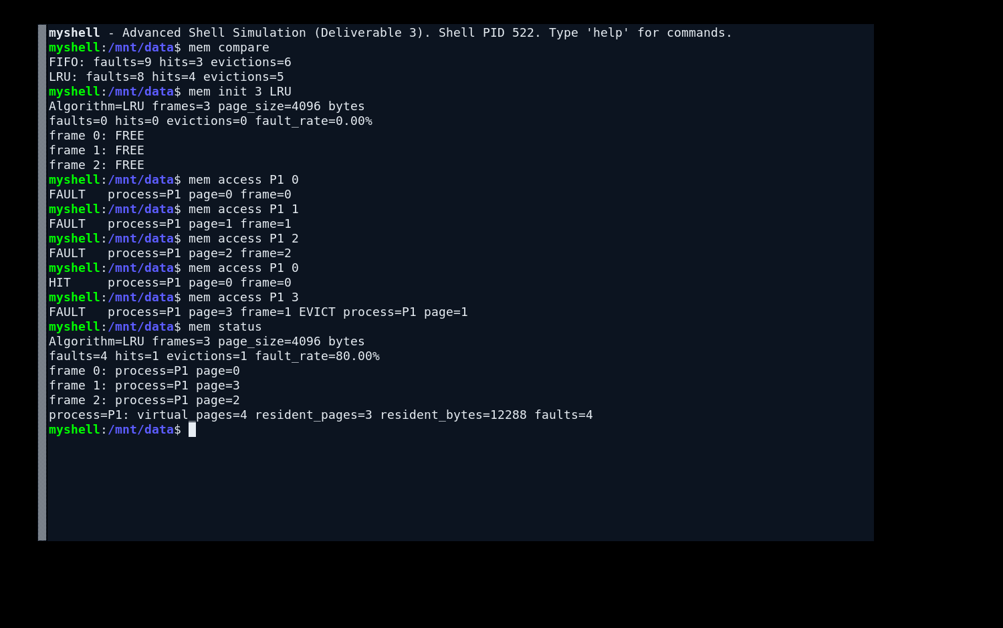
Figure 2. Comparison of FIFO and LRU page replacement algorithms, showing page faults, hits, and evictions.

Synchronization: Producer–Consumer
The classical bounded-buffer problem requires producers to wait when a buffer is full, and consumers wait when it is empty. The implementation uses two counting semaphores, empty and full, along with a mutex lock. The semaphores regulate buffer availability, while the mutex ensures that only one thread modifies the shared buffer at a time. Empty starts at the capacity of the buffer; full starts at zero. Producers acquire empty, lock shared deque, insert value, release lock and signal full; consumers acquire full, lock deque, remove item, release lock and signal empty. Acquisition order avoids holding the mutex while waiting for capacity and prevents typical bounded buffer deadlocks (Huo et al., 2024).
A six-item demo (capacity two) logged every producer and consumer operation and checked that consumed values matched produced values exactly. Both threads joined successfully; the buffer was empty. Mutual exclusion guards the critical region; counting semaphores give correct resource availability. These are concurrent threads in a shell process, not two forked Unix processes. Process-shared semaphores and shared memory would be required to extend the example across separate operating systems processes.
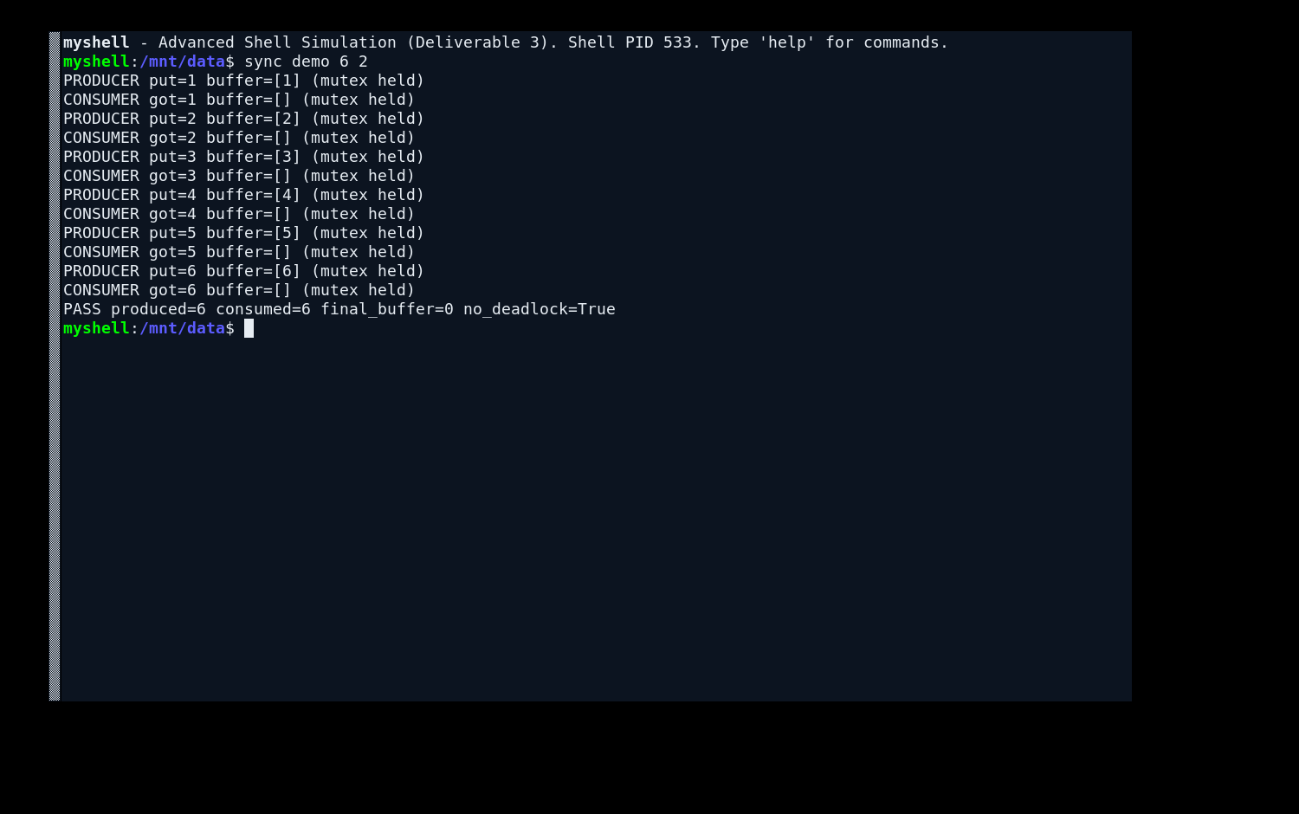
Figure 3. Producer–Consumer synchronization demonstrating mutex-protected shared buffer access and successful completion without deadlock.

Challenges and Improvements
The main paging problem was separating process ownership from virtual allocation and physical residency: resident pages can’t be aliased if process and page numbers are used to identify them; independent insertion and access timestamps keep FIFO and LRU separate. A second challenge was synchronization order: mutex acquired before semaphore empty/full causes the opposite thread to block and deadlock (acquire resource semaphore first then mutex). Acquiring the resource semaphore first, then the mutex, solves this problem. Future work could simulate dirty-page write-backs, backing-storage latency, variable reference traces, page working sets, starvation testing and process-shared synchronization. A larger experimental dataset would also allow confidence intervals and throughput comparisons.

Conclusion
The extended shell shows configurable paging, page fault reporting, FIFO and LRU replacement per process, memory accounting, and ownership-aware deallocation. On the benchmark executed, LRU reduced faults from nine to eight. In a bounded-buffer test, synchronized production and consumption were shown not to cause data loss or deadlock. These concepts reinforce central OS ideas but keep the earlier shell's process management intact. Simulation is suitable for controlled education rather than production kernel memory management.

References
Abbas, S. H., Naser, W. A. K., & Kadhim, L. M. (2022). Study and comparison of replacement algorithms. International Journal of Engineering Research and Advanced Technology, 8(8), 1–6. https://doi.org/10.31695/ijerat.2022.8.8.1
Huo, Y., Lu, X. Q., & Li, Y. (2024). The design and analysis of a producer-consumer model based on multi-mutually exclusive random buffer models. Applied Mathematics, Modeling and Computer Simulation. https://doi.org/10.3233/ATDE231017
Kim, H. (2025). Learning-based page replacement scheme for efficient I/O processing. Scientific Reports, 15, Article 4721. https://doi.org/10.1038/s41598-025-88736-4
Tareef, A., Al-Tarawneh, K., & Alhuniti, O. (2025). An enhanced least recently used page replacement algorithm. Indonesian Journal of Electrical Engineering and Computer Science, 38(1), 417–427. https://doi.org/10.11591/ijeecs.v38.i1.pp417-427

